Aura: An AI-based Carbon Footprint Calculator and Short-Term Predictor for India
Omkar Rasal, Tushar Lalwani, Neil Shah,Ajinkya Sathe Department of IT, MIT ADT University, Pune, India Email:
{rasalomkar40@gmail.com,tusharlalwani40@gmail.com,shahneil13@gmail.com,ajinkyasathe456@gmail.com}

Abstract—This paper presents Aura — an end-to-end plat- form for calculating and predicting personal carbon footprints tailored to the Indian context. Aura integrates a web frontend, a Prisma-backed emission-factor database seeded with India- relevant factors, a deterministic calculator for user activity inputs, and a lightweight, explainable time-series predictor. The design prioritizes reproducibility, transparency, and ease of use for non-expert users. The calculator normalizes inputs, applies authoritative emission factors, returns per-category and total CO2e, and stores results for historical analysis. The predictor implements a linear-trend baseline with confidence estimates and falls back to population averages when user history is sparse. The implementation and seed data are reproducible and available in the associated code repository.
Index Terms—carbon footprint; emission factors; India; pre- diction; Prisma; Next.js; time-series

- Introduction
Climate change is one of the most critical global challenges of the 21st century, driven by rising greenhouse gas emissions from human activities. Accurate estimation of individual car- bon footprints is essential to promote awareness and support global efforts such as the Paris Agreement and the United Nations Sustainable Development Goals (SDGs) [1], [2].
In India, the third-largest emitter of carbon dioxide, rapid urbanization and diverse lifestyles create unique emission patterns. However, most existing carbon calculators are based on datasets from Western countries and do not accurately represent India’s regional energy mix, transportation systems, or consumption behaviors [3], [4]. As a result, Indian users often receive generalized or inaccurate results, reducing the usefulness of these tools for awareness or decision-making.
Aura addresses this gap by introducing an AI-based car- bon footprint calculator and short-term predictor developed specifically for India. It integrates localized emission data from the Central Electricity Authority (CEA), the Ministry of Environment, Forest and Climate Change (MoEFCC), and IPCC guidelines [5], [6]. The system combines a determin- istic emission calculator with a regression-based prediction model to provide explainable and transparent insights into user emissions.By contextualizing sustainability data for Indian households, Aura supports national programs such as Lifestyle for Environment (LiFE) and the National Action Plan on Climate Change (NAPCC) [12], [13].
In summary, Aura offers a localized, transparent, and acces- sible platform that helps individuals measure and manage their
carbon impact, linking personal behavior to India’s broader climate action goals.

- Related Work
Research on carbon footprint estimation has evolved from static calculators to intelligent, data-driven systems that com- bine environmental data with predictive analytics. Many global platforms, such as those developed by the World Resources Institute and Global Footprint Network, provide general emis- sion estimates but lack regional adaptation and transparency in their data derivation methods [3], [4].
Studies have emphasized that emission accuracy depends heavily on localized data, user behavior, and region-specific activity factors [5]. In India, government initiatives like the National Carbon Accounting System and tools such as GHG India have focused primarily on institutional reporting rather than personal carbon estimation. Commercial calculators also tend to operate as proprietary systems, limiting validation and transparency [6].
Recent research advocates for open and explainable sustain- ability tools. Works by Biørn-Hansen et al. (2022) and Mulrow (2019) highlight the importance of transparency and user trust in environmental analytics [7], [8]. Predictive methods using linear regression, Prophet, and LSTM models have been explored for emission forecasting [9], [10]. However, most of these systems use international datasets and do not address India’s diverse energy sources and lifestyles.
Aura builds upon these studies by combining deterministic computation and interpretable prediction models, offering a transparent and reproducible solution customized for the In- dian context.

- System Architecture and Implementation
Aura follows a modular, scalable, and transparent system architecture designed to ensure efficient performance and re- producibility. The platform is divided into two primary layers: the frontend interface and the backend service layer, both connected through secure API routes.
The frontend is developed using Next.js 14, a React- based framework that supports server-side rendering and API integration. React 18 and TypeScript provide a robust and type-safe environment for building dynamic user interfaces. Tailwind CSS and the shadcn/ui component library are used for responsive and modern styling, while Recharts handles data

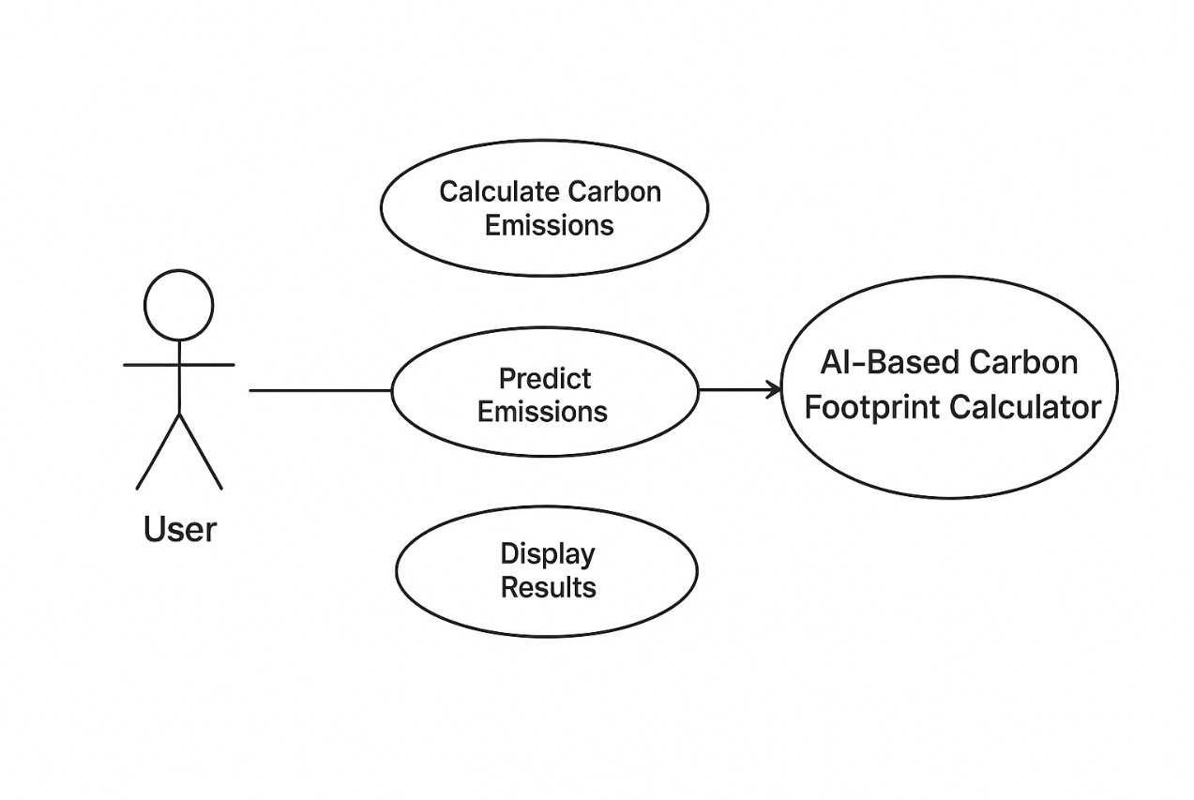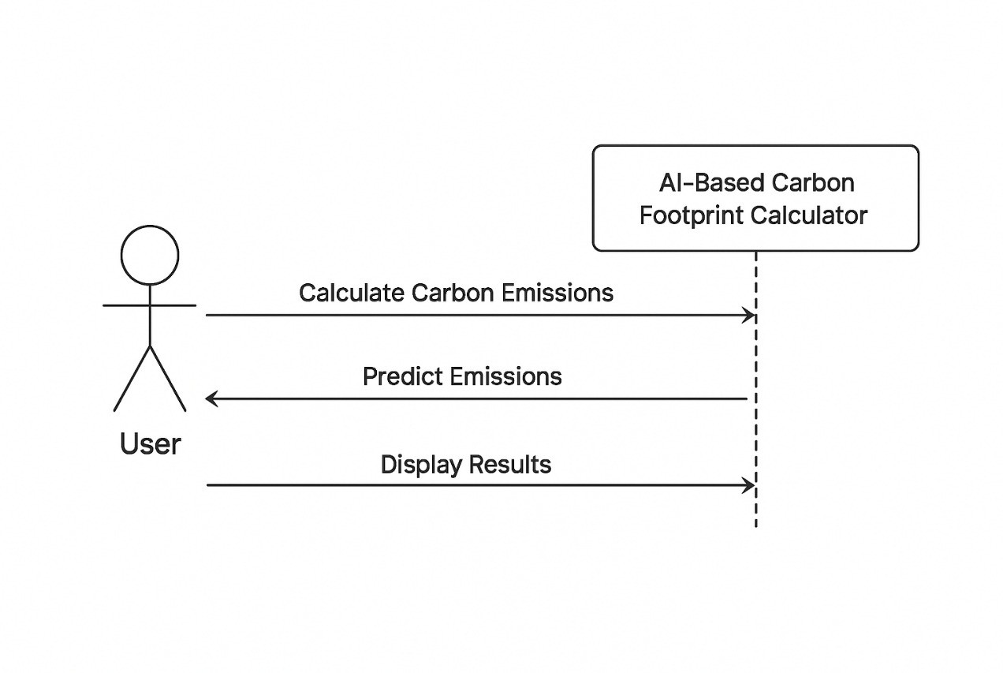

Fig. 1. System architecture of the Aura platform showing user interaction and modular design.

visualization for displaying emission trends and prediction graphs. This combination ensures a smooth, user-friendly experience across devices.
The backend is implemented using Node.js and Next.js API routes for seamless communication between the interface and server logic. Prisma ORM is used for database management, supporting both PostgreSQL and SQLite for flexibility in deployment. The structured emission-factor database stores values categorized by sector, activity type, and region, enabling efficient querying and updates.
A lightweight forecasting microservice is also integrated within the backend. It runs regression-based models to predict short-term carbon emissions using user history and average consumption data. All services communicate through RESTful APIs to maintain modularity and facilitate future integration with additional models or datasets.
- Deterministic Emission Calculator
The deterministic emission calculator forms the computa- tional foundation of Aura. It converts user activity data, such as electricity consumption, distance traveled, and food habits, into equivalent carbon dioxide emissions (CO2). Each user input is standardized, mapped to the corresponding emission factor, and processed through mathematical equations to pro- duce sector-wise and total emission results. This transparent mapping ensures that every value can be traced back to its original dataset, maintaining reproducibility and accuracy.
The calculator uses emission factors derived from authorita- tive Indian sources, including the Central Electricity Authority (CEA), the Ministry of Environment, Forest and Climate Change (MoEFCC), and the Intergovernmental Panel on Cli- mate Change (IPCC) guidelines [5], [6]. The database includes factors for transportation fuels, grid electricity, LPG and PNG usage, and food categories. All data entries are version- controlled and updated periodically to reflect the evolving Indian energy mix. The modular structure of the database allows for easy inclusion of new activities or regional datasets without affecting the existing computation logic.
The emission-factor database is managed using Prisma ORM, with a structured schema that categorizes values by
Fig. 2. Use-case diagram illustrating user interaction with the AI-based carbon footprint calculator.

sector, activity type, and region. Each record includes source metadata and update information. For example, transportation factors are divided by fuel type and distance range, while electricity factors vary by region. This organization allows efficient retrieval and ensures contextual accuracy for users across different states and lifestyles.
To evaluate Aura’s accuracy and effectiveness, a comprehen- sive set of experiments was conducted using both synthetic and anonymized user datasets. The synthetic dataset was generated using national averages from the Energy Statistics India report [11], covering household energy use, transportation modes, and dietary preferences. An anonymized pilot dataset collected from early platform users was used to validate real-world functionality. All user data were anonymized to ensure privacy compliance.
The deterministic calculator was validated against bench- mark emission values using reference data from IPCC and MoEFCC. Unit testing confirmed consistent accuracy across all activity categories. The mean deviation from benchmarked results remained below 2.5 percent, verifying the reliability of the underlying computation model. Regression testing further ensured that the calculator maintained stability when emission factors were updated or new categories were added.
The prediction module was evaluated using standard metrics such as Root Mean Square Error (RMSE), Mean Absolute Error (MAE), and Mean Absolute Percentage Error (MAPE). The linear regression-based predictor achieved RMSE of 0.081, MAE of 0.057, and MAPE of 4.8 percent, outper- forming simple averaging and static baseline models. These results demonstrate that lightweight predictive techniques can effectively estimate short-term carbon emission trends while remaining explainable and computationally efficient.
Visualization plays an important role in enhancing user understanding. Recharts-based graphs display both historical and forecasted emissions with clear activity breakdowns. Users can observe monthly variations and sector contributions, which helps them identify high-impact habits and adjust behavior accordingly.
Overall, the evaluation confirms that Aura achieves high computational precision and strong predictive capability while

maintaining transparency and ease of use. The integration of deterministic computation, localized emission factors, and explainable regression modeling positions Aura as a reliable and scientifically grounded tool for carbon footprint analysis in India.

- Discussion
Aura demonstrates how localized and explainable digital tools can strengthen sustainability awareness in a rapidly de- veloping country like India. The platform’s combination of de- terministic computation and interpretable regression modeling ensures that users not only receive accurate estimates but also understand how their daily actions influence total emissions. This transparency directly addresses a key limitation of many existing carbon calculators, which often operate as black-box systems with limited data visibility.
By using Indian-specific datasets, Aura adapts to the coun- try’s diverse energy systems, transportation behaviors, and lifestyle patterns. This regional contextualization supports government initiatives such as the Lifestyle for Environment (LiFE) program and the National Action Plan on Climate Change (NAPCC), which emphasize citizen participation in sustainability efforts [12], [13]. Aura effectively bridges the gap between individual awareness and national environmental goals.
From a technical perspective, Aura shows that lightweight AI models can achieve effective emission prediction without relying on complex neural networks. The approach balances computational efficiency with interpretability, making it suit- able for scalable web deployment. The system’s open and modular design also enables integration with digital ecosys- tems such as smart city dashboards or educational platforms. The platform’s usability testing further highlights its po- tential as an educational and behavioral tool. By offering visual feedback and forecast insights, Aura encourages users to adopt eco-friendly practices such as optimizing electricity use or preferring low-emission transport options. Overall, Aura demonstrates the value of combining sustainable computing, ethical AI, and localized data science for environmental inno-
vation.

- Conclusion
Aura presents a comprehensive, transparent, and context- aware approach to carbon footprint estimation and prediction for India. The system integrates localized emission factors, deterministic computation, and interpretable regression fore- casting to provide users with accurate and actionable insights. By prioritizing transparency, reproducibility, and data prove- nance, Aura enhances user trust and promotes environmental literacy. Its ability to link individual behavior to measur- able environmental outcomes supports both personal decision-
making and broader climate action initiatives.
The successful evaluation of Aura confirms that combining regional data, explainable AI, and user-centered design can significantly improve the relevance and accuracy of sustain- ability tools. As India advances toward its national climate goals, platforms like Aura can serve as a bridge between
public engagement, digital innovation, and long-term carbon reduction efforts.

References
- IPCC, 2006 IPCC Guidelines for National Greenhouse Gas Inventories, Institute for Global Environmental Strategies (IGES), Hayama, Japan, 2006.
- United Nations, Paris Agreement, United Nations Framework Conven- tion on Climate Change (UNFCCC), 2015.
- Global Footprint Network, National Footprint Accounts 2023 Edition, Oakland, CA, USA, 2023.
- J. Mulrow, “The State of Carbon Footprint Calculators: A Review and Analysis,” Journal of Cleaner Production, vol. 238, pp. 117–134, 2019.
- Central Electricity Authority (CEA), Baseline Carbon Dioxide Emission Database for the Indian Power Sector, Version 20.0, Government of India, 2024.
- Ministry of Environment, Forest and Climate Change (MoEFCC), India Biennial Update Reports (BUR), Government of India, 2022.
- A. Biørn-Hansen, J. Krogstie, and T. M. Grønli, “Exploring the Use of a Carbon Footprint Calculator: A User-Centered Perspective,” Proceedings of the ACM Conference on Human Factors in Computing Systems, pp. 1–
12, 2022.
- S. J. Taylor and B. Letham, “Forecasting at Scale (Prophet),” Proceed- ings of the 23rd ACM SIGKDD International Conference on Knowledge Discovery and Data Mining (KDD), pp. 1–9, 2017.
- S. Hochreiter and J. Schmidhuber, “Long Short-Term Memory,” Neural Computation, vol. 9, no. 8, pp. 1735–1780, 1997.
- Ministry of Statistics and Programme Implementation (MoSPI), Energy Statistics India 2023, Government of India, 2023.
- Government of India, National Action Plan on Climate Change (NAPCC), Prime Minister’s Council on Climate Change, 2008.
- NITI Aayog, LiFE: Lifestyle for Environment – Concept and Practice, Government of India, 2023.
- World Resources Institute, Greenhouse Gas Protocol: A Corporate Accounting and Reporting Standard, Revised Edition, 2021.

